Agriculture Contingency Plan
for District : Muzaffarpur

1.0 District Agriculture profile
1.1 | Agro-Climatic/Ecological Zone
 | Agro Ecological Sub Region (ICAR) | Eastern Plain, Hot Subhumid (moist) Eco-Region (13.1)
 | Agro-Climatic Zone (Planning Commission) | Middle Gangetic Plain Region (IV)
 | Agro Climatic Zone (NARP) | North West Alluvial Plain Zone (BI-1)
 | List all the districts or part thereof falling  under the NARP Zone | Zone 1 (Muzaffarpur, Saran, Sivan, E. Champaran, Gopalganj, W.Champaran, Sitamarhi, Seohar, Vaishali,  Darbhanga, Madhubani and Samastipur
 | Geographic coordinates of district headquarters | Latitude | Longitude | Altitude
 |  | 26⁰ 04’ – 26.07’ N | 84⁰ 5’ – 85⁰ 5’E | 70 m
 | Name and address of the concerned ZRS/ ZARS/ RARS/ RRS/ RRTTS | Zonal Research Station, Dholi
 | Mention the KVK located in the district | KVK, Muzaffarpur

1.2 | Rainfall | Normal RF(mm) | Normal Rainy days (number) | Normal Onset  ( specify week and month) | Normal Cessation (specify week and month)
 | SW monsoon (June-Sep) | 1010.5 | 46 | 2nd week of June | 4th week of September
 | NE Monsoon(Oct-Dec) | 79.6 | 03 | 1st week of October | 2nd week of October
 | Winter (Jan- Feb) | 28.5 | 00
 | Summer (Mar-May) | 80 | 8
 | Annual | 1198.6 | 57
1.3 | Land use pattern of the district (latest  statistics) | Geographical area | Cultivable area | Forest area | Land under non- agricultural  use | Permanent pastures | Cultivable wasteland | Land under Misc. tree crops and  groves | Barren and uncultivable land | Current fallows | Other fallows
 | Area (‘000 ha) | 315 | 219 |  | 56.1 | 0.2 | 0.3 | 12.7 | 4.6 | 1.07

# Source: - SREP, District Agriculture Office, Muzffarpur

1. 4 | Major Soils | Area (‘000 ha) | Percent (%) of total
 | Sandy Soils | 3.337 | 0.92
 | Coarse Sandy Loam Soils | 83.140 | 23.13
 | Fine Sandy Loam Soils | 57.820 | 16.08
 | Clayey Soils | 3.347 | 0.93
 | Saline/ Calcareous Soils | 211.812 | 58.92
1.5 | Agricultural land use | Area (‘000 ha) | Cropping intensity %
 | Net sown area | 219 | 130.1%
 | Area sown more than once | 66
 | Gross cropped area | 285

1.6 | Irrigation | Area (‘000 ha)
 | Net irrigated area | 81.0
 | Gross irrigated area | 81.2
 | Rainfed area | 138
 | Sources of Irrigation | Number | Area (‘000 ha) | Percentage of total irrigated area
 | Canals – (Gandak Project) | 01 | 2.5 | 3.08
 | Tanks | 194 | 2.9 | 3.6
 | Open wells
 | Bore wells | 33845 | 66.4 | 81.8
 | Lift irrigation schemes
 | Micro-irrigation
 | Other sources (please specify) well etc. |  | 9.6 | 11.8
 | Total Irrigated Area |  | 81.1
 | Pump sets | 54000
 | No. of Tractors | 6870
 | Groundwater availability and use* (Data source: State/Central Ground water  Department /Board) | No. of blocks/ Tehsils | (%) area | Quality of water (specify the problem such as high levels of arsenic, fluoride,  saline etc)
 | Over exploited
 | Critical

 | Semi- critical
 | Safe | 15
 | Waste water availability and use
 | Ground water quality | Ground water has some percentage of Iron in this district
*over-exploited: groundwater utilization > 100%; critical: 90-100%; semi-critical: 70-90%; safe: <70%
1.7 Area under major field crops & horticulture (as per latest figures of 2009-10 )
1.7 | Major field crops cultivated | Area (‘000 ha)
 |  | Kharif |  |  | Rabi
 |  | Irrigated | Rainfed | Total | Irrigated | Rainfed | Total | Summer | Grand total
 | Rice | 11.9 | 107.4 | 119.3 | - | - | - | - | 119.3
 | Wheat | - | - | - | 62.5 | 33.6 | 96.1 | - | 96.1
 | Maize | 4.3 | 8.8 | 13.1 | 4.3 | 10.6 | 14.9 | - | 28
 | Pulses | - | - | - | - | 9.2 | 9.2 | - | 9.2
 | Oilseeds | - | - | - | - | 4.5 | 4.5 | - | 4.5
Source: - SREP, District Agriculture Office, Muz
 | Horticulture crops - Fruits | Area (‘000 ha)
 |  | Total | Irrigated | Rainfed
 | Litchi | 7.5 | 4.5 | 2.9
 | Mango | 8.9 | 5.8 | 3.1
 | Banana | 4.9 | 3.5 | 1.4
 | Citrus | 0.5 | 0.2 | 0.3
 | Guava | 1.0 | 0.6 | 0.4
 | Horticulture crops - | Total | Irrigated | Rainfed

 | Vegetables
 | Potato | 10 | 10
 | Cauliflower | 3.6 | 3.6
 | Cabbage | 2.7 | 2.7
 | Onion | 2.4 | 2.4
 | Tomato | 3.4 | 3.4
 | Chilli | 1.7 | 1.7
 | Bottle gourd | 1.3 | 1.3
 | Ladies finger | 2.7 | 2.7
 | Brinjal | 2.7 | 2.7
 | Medicinal and Aromatic crops | Total | Irrigated | Rainfed
 | Mentha | 0.002 |  | 0.002
 | Lemon Grass | 0.001 |  | 0.001
 | Citronella | 0.35 |  | 0.35
 | Mari gold | 0.001 | 0.001
 | Plantation crops | Total | Irrigated | Rainfed
 | Fodder crops | Total | Irrigated | Rainfed
 | Barseem | 0.7 | 0. 7

 | Oat | 0.1 |  | 0.1
 | Sorghum | 0.9 |  | 0.9
 | Napier | 0.8 |  | 0.8
 | Total fodder crop area | 1.1 |  | 1.1
 | Grazing land
 | Sericulture etc
Source- DAO, Muzaffarpur
1.8 | Livestock |  | Male (‘000) |  |  | Female (‘000) |  |  | Total (‘000)
 | Non descriptive Cattle (local low yielding) |  | 48.6 |  |  | 93.9 |  |  | 142.5
 | Crossbred cattle |  | 24.1 |  |  | 74.9 |  |  | 99.0
 | Non descriptive Buffaloes (local low yielding) |  | 21.7 |  |  | 150.0 |  |  | 171.7
 | Graded Buffaloes |  | 6.9 |  |  | 59.4 |  |  | 66.3
 | Goat |  | 117.3 |  |  | 282 |  |  | 399.3
 | Sheep |  | 3.3 |  |  | 3.5 |  |  | 6.8
 | Others (Pig) |  | 13.5 |  |  | 5.7 |  |  | 19.2
 | Commercial dairy farms (Number)
1.9 | Poultry |  | No. of farms |  |  | Total No. of birds (‘000)
 | Commercial |  |  |  |  | 187.5
 | Backyard |  |  |  |  | 17.3
1.10 | Fisheries
 | A. Capture
 | i) Marine | No. of fishermen |  | Boats |  |  | Nets |  |  | Storage facilities (Ice plants etc.)
 |  |  |  | Mechanized | Non- mechanized |  | Mechanized (Trawl nets, Gill nets) | Non-mechanized (Shore Seines, Stake & trap nets)

 | ii) Inland (Data Source: Fisheries Department) | No. Farmer owned ponds |  |  | No. of Reservoirs |  |  | No. of village tanks
 |  | 2000 |  |  | 931 |  |  | 1541 (Govt.)
 | B. Culture
 |  |  | Water Spread Area (ha) |  |  | Yield (t/ha) |  |  | Production (‘000 tons)
 | i) Brackish water
 | ii) Fresh water (Data Source: Fisheries  Department) |  | 2820 (Govt.) |  |  | 0.5 |  |  | 14.000
Source: - SREP, District Agriculture Office, Muz & District Animal Husbandry & Fishery Officer, Muzaffarpur
1.11 Production and Productivity of major crops (Average of last 5 years: 2004-08)
1.11 | Name of crop | Kharif |  | Rabi |  | Summer |  | Total |  | Crop residue as fodder (‘000  tons)
 |  | Production ('000 t) | Productivity (kg/ha) | Production ('000 t) | Productivity (kg/ha) | Production ('000 t) | Productivity (kg/ha) | Production ('000 t) | Productivity (kg/ha)
Major Field crops (Crops identified based on total acreage)
 | Rice | 150.7 | 1567 |  |  |  |  | 150.7 | 1567
 | Maize | 19.7 | 1500 | 95.4 | 6400 |  |  | 115.1 | 3950
 | Wheat |  |  | 162.1 | 2100 |  |  | 162.1 | 2100
 | Pulses |  |  |  |  | 6.3 | 0.7 | 6.3 | 0.7
 | Oil Seeds |  |  | 5.4 | 1150 |  |  | 5.4 | 1150
Major Horticultural crops (Crops identified based on total acreage) Production('000 t)
 | Litchi |  |  |  |  |  |  | 55.8
 | Mango |  |  |  |  |  |  | 93.7
 | Guava |  |  |  |  |  |  | 12.5
 | Banana |  |  |  |  |  |  | 201.6
 | Lemon |  |  |  |  |  |  | 4.7
 | Papaya/Aonla etc. |  |  |  |  |  |  | 12.3

1.12 | Sowing window for 5 major field crops  (start and end of normal  sowing period) |  |  | Rice |  | Pigeonpea | Wheat |  |  | Maize |  |  | Lentil
 | Kharif- Rainfed |  |  | 2nd week of June |  | 3rd week of June -  2nd week of July | - |  |  | 3rd week of May-2nd week  of June |  |  | -
 | Kharif-Irrigated |  |  | 2nd week of June -  3rd week of June |  | - | - |  |  | - |  |  | -
 | Rabi- Rainfed |  |  | - |  | - | 4th week of October - 1st week of November |  |  | - |  |  | 2nd week of  October - 1st week of November
 | Rabi-Irrigated |  |  | - |  | - | 2nd week of November -  2nd week of December |  |  | 2nd week of October -  3rd week of November |  |  | 2nd week of Oct. –  2nd week of Nov.
1.13 |  | What is the major contingency the district is prone to? (Tick mark) |  |  |  |  |  | Regular |  |  | Occasional | None
 |  | Drought |  |  |  |  |  |  |  |  | 
 |  | Flood |  |  |  |  |  | 
 |  | Cyclone |  |  |  |  |  |  |  |  |  | 
 |  | Hail storm |  |  |  |  |  |  |  |  |  | 
 |  | Heat wave |  |  |  |  |  | 
 |  | Cold wave |  |  |  |  |  |  |  |  | 
 |  | Frost |  |  |  |  |  |  |  |  | 
 |  | Sea water intrusion |  |  |  |  |  |  |  |  |  | 
 |  | Pests and disease outbreak |  |  |  |  |  |  |  |  | 
1.14 |  |  | Include Digital maps of the district for |  | Location map of district within State as Annexure I |  |  |  | Enclosed: Yes
 |  |  |  |  | Mean annual rainfall as Annexure II |  |  |  | Enclosed: Yes
 |  |  |  |  | Soil map as Annexure III |  |  |  | Enclosed: Yes

Annexure I

Agro climatic Zones of Bihar
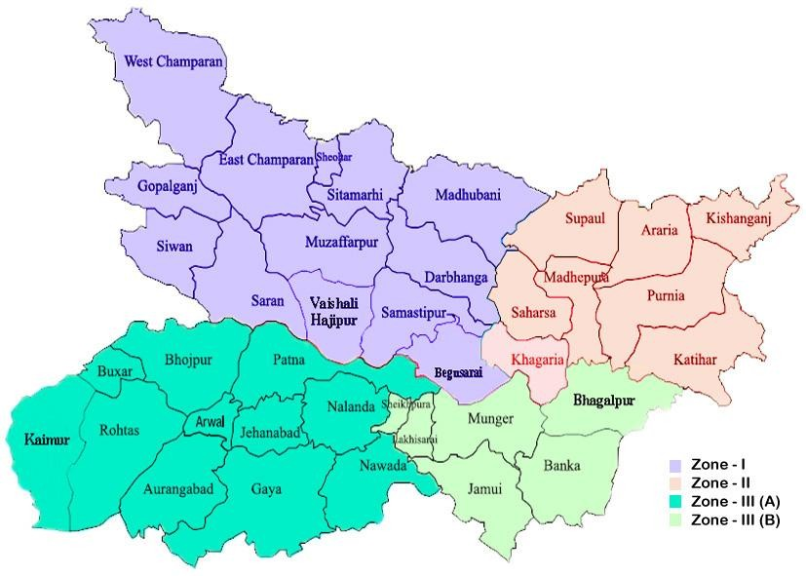
Source: krishi.bih.nic.in

Annexure II

Mean annual rainfall (mm)
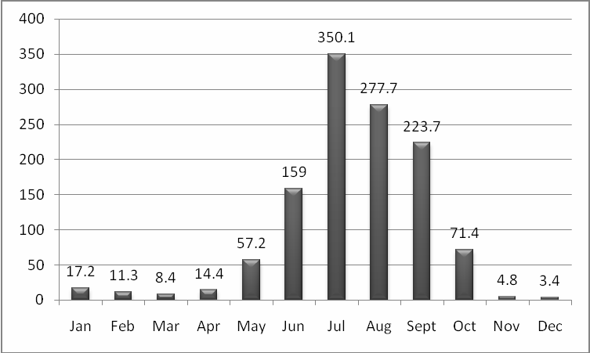

Annexure-III

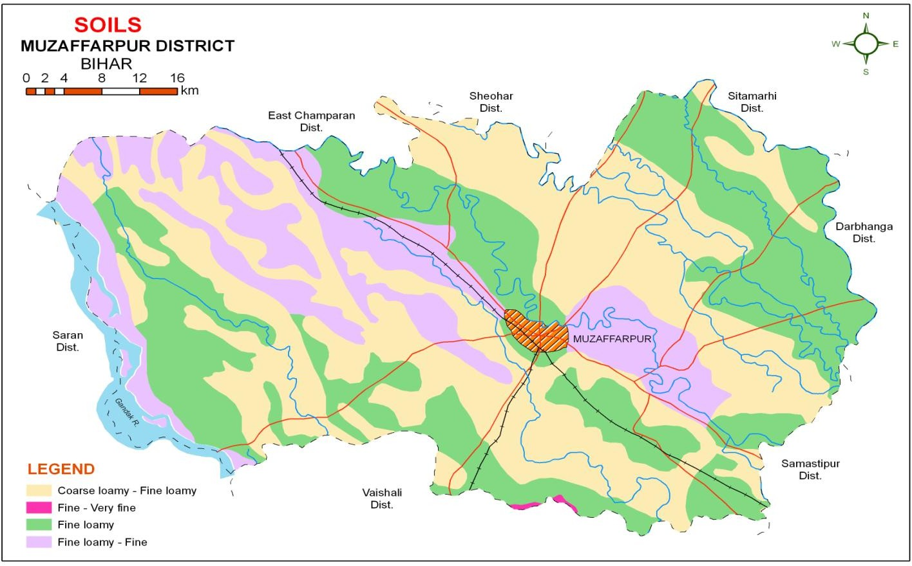

Source : NBSS& LUP, Regional Centre, Kolkata

Strategies for weather related contingencies for Drought and Rainfed situation

Condition |  |  | Suggested Contingency measures
Early season drought  (delayed onset) | Major Farming situation | Normal Crop / Cropping system | Change in crop / cropping system including variety |  | Agronomic measures | Remarks on Implementation
Delay by 2 weeks  1st week of July | Up land | Rice-Wheat  Pigeonpea-Greengram | Early Rice – Wheat  Pigeonpea – Greengram |  | Normal package of Practices,  Direct sowing of rice | -
 | Medium land | Rice- Wheat | Rice-Wheat
 | Lowland | Rice – Wheat | Rice – Wheat  Medium to long duration
Condition |  |  | Suggested Contingency measures
Early season drought  (delayed onset) | Major Farming situation | Normal Crop/cropping system | Change in crop/cropping system | Agronomic measures |  | Remarks on Implementation
Delay by 4 weeks  3rd week of July | Upland  Fine loamy soils | Pigeonpea-Greengram | Early Rice – Wheat Pigeonpea – Greengram  Rice- Prabhat, Dhanlaxmi, Richharia, Turanta Saroj  Pigeonpea – Bahar, Pusa-9 | - |  | Seeds from RAU, Pusa, NSC, TDC ,  BRBN etc.
 |  | Rice-Wheat | Rice-Wheat  Rice- Prefer Medium to short duration varieties like  Saroj (100-110d), Birsa Dhan-201 (100- 115d) | - Direct seeding of rice with medium duration drought tolerant varieties with pre emergence herbicide  application under sufficient soil moisture conditions followed up with a post-emergence  weedicide application 20- 25 days later for effective

 |  |  |  | weed management.
- Raise staggered community nursery preferably with medium duration varieties in mid and lowlands
- Normal sowing of rice can be used with enhanced NPK to boost the early vegetative growth in late plantings under sufficient moisture
- Interculture for timely
 |  |  |  | weed control in direct
 |  |  |  | seeded rice
 | Medium land | Rice – Wheat | Rice-Wheat | - Where field is moist,  direct seeding of medium duration varieties (125 days) can be done during second fortnight of July in midlands. Post- emergence herbicide application use is essential  - Use mat nursery/ dapog nursery , mat nursery (dapog method) can be raised for quick availability of young seedlings for transplanting of medium duration varieties by first fortnight of August in  mid and Lowlands
Direct sowing / 20d old dapog seedlings with medium to short duration varieties
– BR34, Rajendra Dhan-201(130-135d), Rajendra Bhagwati,
 | Lowland | Rice – Wheat | Rice- Direct/ dapog seedlings with
 |  |  | Rajshree, Santosh , Sita, Rajendra
 |  | Makhana (in ponds) | Suwasni, Rajendra Sweta, Swarna sub-1
 |  | Var. local

- Raise staggered
community nursery preferably with short duration varieties in mid and lowlands
- Transplant with 30-35 days old seedling may be used with 3-4 seedling per hill with close spacing.
- Enhanced dose of nitrogen with full basal dose of NPK at the time of transplanting to boost the early vegetative growth in late plantings under sufficient moisture
- Timely interculture for weed control in direct seeded rice
- Life saving irrigation

Condition |  |  | Suggested Contingency measures
Early season  drought (delayed onset) | Major Farming situation | Normal Crop/cropping system | Change in crop/cropping system | Agronomic measures | Remarks on Implementation
Delay by 6 weeks  1st week of August | Upland  Fine loamy soils | Rice-Wheat Pigeonpea-Greengram | Early Rice – Wheat  Blackgram/ Finger millet-Wheat  Blackgram - T-9, Navin, Pant Urd-30 , Pant Urd-19 | Direct sowing of Rice, Application of Potassic fertilizer at vegetative stage, Dapog seedlings can be used under moist conditions | Seeds from RAU, Pusa, NSC, TDC ,  BRBN etc.
Finger milletRAU 7&8 Coimbatore-1
Rice- Prabhat, Dhanlaxmi,

 |  |  | Richharia, Turanta Saroj
 | Medium land | Rice – Wheat | Rice (Short duration)-Wheat Blackgram/ Finger millet-Wheat | Interculture
Blackgram- T-9, Navin, Pant Urd-30 , Pant Urd-19
Finger milletRAU 7&8
 |  |  | Rice (Short duration)-Wheat Rice- Prabhat, Dhanlaxmi, Richharia, Turanta Saroj | - Mat nursery (dapog method)/ Community nursery can be raised for quick availability of young seedlings for transplanting of medium duration varieties by first fortnight of August  - Direct seedling of Rice  - Raise staggered community nursery preferably with medium duration varieties in mid and lowlands  - Enhanced basal dose of
 | Lowland | Rice-Wheat-Greengram | Rice (Short Duration)-Wheat Rice- Prabhat, Dhanlaxmi, Richharia, Turanta, Saroj  If dry spell continues, direct seeding of short duration rice varieties (100 days) can be done in midlands by first fortnight of August and extra short duration (70-75 days) up to 25th  August
 |  |  |  | NPK to boost the early
 |  |  |  | vegetative growth
 |  |  |  | - Application of fertilizers
 |  |  |  | especially phosphorous
 |  |  |  | and potash to be ensured
 |  |  |  | under late transplanted
 |  |  |  | conditions in severely
 |  |  |  | affected districts
 |  |  |  | - Life saving irrigation

Condition |  |  |  | Suggested Contingency measures
Early season  drought (delayed onset) | Major Farming situationª | Normal  Crop/cropping system^{b} | Change in crop/cropping system^{c} |  | Agronomic measures^{d} | Remarks on Implementation^{e}
Delay by 8 weeks  3rd week of August | Upland  Fine loamy soils | Rice-Wheat | Early Rice – Sept. Pigeonpea  Rice- Prabhat, Dhanlaxmi, Richharia, Turanta, Saroj |  | - Moisture conservation  - Inter cultivation  - Sowing of rabi crops such as Wheat, Lentil, Chickpea, Pea, Mustard (Pusa Mahak, RAU TS17), Linseed (Garima) and Vegetables | Seeds from RAU, Pusa, NSC, TDC ,  BRBN etc
 | Medium land | Maize-Wheat | Sesame –Rabi maize  Sesame-Late Wheat Sesame – Krishna, Pragati |  | - Supply of contingency crop seeds of Toria, Maize (QPM varieties, Swann composite- 65-70 days; HM-4 hybrid baby corn), Arhar (Bahar, NDA1, Pusa 9), Urd (Navin and T9), Cowpea and Horsegram need to be ensured for taking up of sowing in September in midlands  Fodder varieties of Jowar, Maize, Bajra in combination with legumes (cowpea and horsegram) can be taken up wherever feasible to meet the fodder requirements in deficit  rainfall districts
 |  | Pigeonpea – Greengram | September Pigeonpea-Greengram Sept.Pigeonpea–Pusa-9, Sharad  Narendra Arhar-I
 |  | Rice-Wheat | Direct seeded rice (DSR) with short duration (80-90 days) varieties (Turanta dhan, Prabhat, Anjali, Vandana, CR- Dhan-40 etc.) can be taken up in midlands till the end of August subject to availability of at least one assured |  | - Direct seeding of rice  - Mat nursery (dapog method)/ Community nursery can be raised for quick availability of young seedlings for  transplanting of medium

 |  |  | irrigation  Early Rice-Prabhat, Dhanlaxmi,  Richharia, Turanta | duration varieties by first fortnight of August  - Use of 20 days old dapog seedling in rice.  - Enhanced basal dose of NPK in rice to boost early vegetative growth  - Supply of contingency crop seeds of Toria, Maize (QPM varieties, Swann composite- 65-70 days; HM-4 hybrid baby corn), Arhar (Bahar, NDA1, Pusa 9), Urd (Navin and T9), Cowpea and Horsegram need to be ensured for taking up of sowing in September in midlands  - Fodder varieties of Jowar, Maize, Bajra in combination with legumes (cowpea and horsegram) can be taken up wherever feasible to meet the  fodder requirements in deficit rainfall districts
 | Lowland | Rice- Potato | Rice-Potato/Wheat  Rice- Rajshree, Santosh , Sita Rajendra Suwasni, Rajendra Sweta | - Double transplanting of rice  (karuhan) can be done with 30 + 45 days old seedlings of long duration or photosensitive varieties up to 30th August with close planting (40-45 hills per square meter)  - Application of organic manure and vermi compost initially for Rice and other crops.  - Sowing of rabi crops such

as Wheat, Lentil, Chickpea, Pea, Mustard (Pusa Mahak, RAU TS17), Linseed (Garima) and Vegetables can be taken up on time for maximizing productivity from lowlands with support from the government for timely supply of inputs and in a way rabi production would compensate the production loss during kharif.
- Fodder varieties of Jowar, Maize, Bajra in combination with legumes (cowpea and horsegram) can be taken up wherever feasible to meet the fodder requirements in deficit
rainfall districts
 |  | Rice-wheat-Green gram | Sept. Pigeonpea-Greengram Sesame-Rabi maize  Pigeonpea – Bahar, Pusa-9, Narendra Arhar-I  Sesame – Krishna, Pragati | Normal practices for Sesame, Pigeonpea

Condition |  |  | Suggested Contingency measures
Early season drought (Normal onset) | Major Farming situation | Normal Crop/cropping system | Crop management | Soil nutrient & moisture conservation measures | Remarks on Implementation
Normal onset followed by 15-20 days dry spell after sowing leading to poor germination/ crop stand etc. | Upland | Rice-Wheat  Rice- Prabhat, Dhanlaxmi, Richharia, Turanta, Saroj | - Gap filling  - Thinning | - Timely interculture for weed control in direct seeded rice  - Mulching  - Conservation tillage  - Life saving irrigation | -
 | Medium land | Maize-wheat  Maize - Shaktiman-1,2,3,4, 5  Suwan, Ganga-11, Deoki, Pusa early hybrid Maka-3 | - Gap filling
 |  | Pigeonpea-Greengram  Pigeonpea – Bahar, Pusa-9 Narendra Arhar-I | - Pre-sowing irrigation  - Higher seed rate  - Gap filling through Dapog nursery
 | Lowland | Rice-Wheat-Green gram  Rice- Rajshree, Santosh , Sita, Rajendra Suwasni,  Rajendra Sweta | - Gap filling through Dapog nursery
Condition |  |  | Suggested Contingency measures
Mid season drought | Major Farming | Normal Crop/cropping system | Crop management | Soil nutrient & | Remarks on
(long dry spell, | situation |  |  | moisture conservation | Implementation
consecutive 2 weeks |  |  |  | measures
rainless (>2.5 mm)
period)
At vegetative stage | Upland | Rice- wheat | - Gap filling of existing crop  - Postponement of top dressing | - Inter culturing  - Mulching  - Conservation tillage  - Foliar spray with (1%) Urea or MOP  - Life saving irrigation
 | Medium land
 | Lowland

Condition |  |  | Suggested Contingency measures
Mid season  drought (long dry spell) | Major Farming situation | Normal Crop/cropping system | Crop management | Soil nutrient &  moisture conservation measures | Remarks on Implementation
At flowering/ fruiting stage | Rice – Wheat | Rice | - Adopt IPM practices  - Foliar application with 2% Urea or MOP | - Interculture  - Mulching  - Conservation tillage  - Life saving irrigation

Condition |  |  | Suggested Contingency measures
Terminal drought (Early withdrawal of monsoon) | Major Farming situation | Normal Crop/cropping system | Crop management | Rabi Crop planning | Remarks on Implementation
 | Upland | Rice – wheat/ maize / Vegetables | - Foliar spray with (1%) Urea or MOP  - Adopt IPM practices  - Mulching  - Life saving irrigation | - Open the furrow during evening and left furrow open overnight and plank in the next morning before sunrise for growing of early rabi crops like wheat, Rabi Maize/Pulses /Oilseeds/ Vegetables | -
 | Medium Land
 | Lowland

Drought - Irrigated situation

Condition |  |  | Suggested Contingency measures
 | Major Farming situation | Normal Crop/cropping system | Change in crop/cropping system | Agronomic measures | Remarks on Implementation
Delayed release of water in canals due  to low rainfall | Not applicable
Limited release of water in canals due to low rainfall

Condition |  |  | Suggested Contingency measures
 | Major Farming  situation | Normal Crop/cropping system | Change in crop/cropping system | Agronomic measures | Remarks on Implementation
Non release of water in canals under
delayed onset of monsoon in catchment

Condition |  |  | Suggested Contingency measures
 | Major Farming situation | Normal Crop/cropping system | Change in crop/cropping system | Agronomic measures | Remarks on Implementation
Lack of inflows into tanks due to insufficient  /delayed onset of monsoon | Upland, Medium Land , Lowland | Rice-Wheat | Short duration of Rice – Pigeonpea | Direct sowing of rice, Life saving irrigation, Mulching,  Application of organic manure and vermicompost | Seeds from RAU, Pusa, NSC, TDC ,  BRBN etc

Condition |  |  | Suggested Contingency measures
 | Major Farming situation | Normal Crop/cropping system | Change in crop/cropping system | Agronomic measures | Remarks on Implementation
Insufficient groundwater recharge due to low rainfall | Upland, Medium Land , Lowland | Rice-Wheat | Short duration of Rice – Pigeonpea | Life saving irrigation, Mulching,  Application of organic manure and vermi compost | Seeds from RAU, Pusa, NSC, TDC ,  BRBN etc

Unusual rains (untimely, unseasonal etc) (for both rainfed and irrigated situations)
Condition | Suggested contingency measure
Continuous high rainfall in a short span leading to water  logging | Vegetative stage | Flowering stage | Crop maturity stage | Post harvest
Rice, Maize, Pigeonpea,  vegetables | Provide drainage | Provide drainage

Horticulture | Provide drainage | Provide drainage
Mango | Provide drainage | Provide drainage | Provide drainage | Safe storage and  transportation
Litchi | Provide drainage | Provide drainage | Provide drainage
Banana | Provide drainage | Provide drainage | Provide drainage
Guava | Provide drainage | Provide drainage | Provide drainage
Heavy rainfall with high
speed winds in a short span²
Rice | Replanting with Dapog nursery seedling ,  Gap filling,  Kharuhan (double transplanting) method
Maize | Earthing up
Pigeonpea | Earthing up
Vegetables | Grow nursery on raised bed  and poly tunnel
Horticulture
Mango Litchi Banana  Guava | Re planting | Provide wind breaks to reduce the wind speed | Provide wind break
Outbreak of pests and diseases due to unseasonal rains | Vegetative stage | Flowering stage | Crop maturity stage | Post harvest
Rice | - Seedling treatment with  granular insecticide – Cartap hydrochloride or phorate 10G or carbofuran 3G.  - Maintain shallow water in nursery beds  - Providing good drainage. | - Use copper fungicides  against Bacterial leaf blight.  - Split application of N fertilizer (3-4 times) | - Harvest at physiological  maturity | - Proper drying and safe storage

Maize | - Drainage, and yellowing mainly due to nitrogen deficiency apply N split doses  - Application of granular insecticides viz. Thimet 10g, or Carbofuran 3g. in whorl of maize | - Foliar blight control through Mancozeb @ 2.5g/l  Or Zineb/ Maneb @ 2.5-4 g/lit of water (2-4 applications at 8-  10 days interval) | - Cob harvesting from standing crop  - Harvest at physiological maturity | - Storage in safe places like farmer warehouse/tent covering of produce  - Ensure 10-12% moisture in grains before storage  - Proper dying
Pigeonpea | - Provide drainage  - Seed treatment with 1 g carbendizim +2g thiram/kg seed. | Provide drainage | Provide drainage | - Proper dying  - Storage at safe place and transportation
Horticulture
Vegetables | - Drainage management | - Drainage management | - Drainage management
Mango | Anthracnose:-  The foliar infection can be controlled by spraying of copper oxychloride (0.3%)  Use bio control agent viz Streptosporangium pseudovulgare  Bacterial canker: Regular inspection of orchards, sanitation and seedling certification are  recommended as preventive measures.  Mango stones for raising seedlings (root stock) should always be taken from healthy fruits.  Use of wind-breaks helps in reducing brushing/ wounding and thus reduces the chance of infection. | Anthracnose:-  Apply Carbendazim/ Thiophanate methyl (1g/lit) to control of Anthracnose.  Blossom infection can be controlled effectively by spraying of Bavistin (0.1%) at 15 days interval.  Mango powdery mildew: Spray wettable sulphur(0.2%) & calixin or karathane (0.1% ) during second week of December | Mango powdery mildew: Prune diseased leaves and malformed panicles harbouring the pathogen to reduce primary inoculum load.  Spray wettable sulphur (0.2%) when panicles are 3-4” in size  Spray dinocap (0.1%) 15-20 days after first spray.  Spray tridemorph (0.1%) 15-20 days after second spray.  Spraying at full bloom needs to be avoided.  Mango bacterial canker: Three sprays of Streptocycline (200 ppm) at 10 days intervals reduce fruit  infection.  In severe infection, spraying of Streptocycline (300 ppm) or copper oxychloride  (0.3%) is more effective. | Harvest at proper time  Anthracnose:-  Pre-harvest sprays of hexaconazole (0.01%) or  Carbendazim (0.1%) at 15 days interval should be done in such a way that the last spray falls 15 days prior to harvest.  Diseased leaves, twigs, and fruits, should be collected and burnt to avoid the spread for next season
Litchi | Fruit Fly: | Fruit Fly: | Harvest at proper time | Fruit Fly:
 | Monitor adult fruit flies | First Spray delta menthrin |  | Collect all fallen infested
 | emrgence by using methyl | 0.0025% plus molasses 0.1% . |  | fruits and put in a drum
 | eugenol or sex pheromone | after 10-12 days spray fenthion |  | covered with fine wire
 | traps. | 0.05% + molasses 0.1% |  | mesh.
 |  | followed by dimethoate 0.045% |  | Harvest fully matured fruits
 |  | + molasses 0.1% if required |  | one week earlier to escape
 |  |  |  | egg laying
Banana | Provide drainage | Provide drainage | Harvest at proper time
Guava | Provide drainage | Provide drainage | Harvest at proper time

Floods
Condition | Suggested contingency measures
Transient water logging/ partial inundation¹ | Seedling / nursery stage | Vegetative stage | Reproductive stage | At harvest
Rice | - Provide drainage  - Re transplanting through dapog nursery seedlings  - Gap filling | - Provide drainage  - Gap filling  - 40-45 days old seedlings may be used  - Kharuhan (double transplanting) mehod | - Provide drainage  - Harvest at physiological maturity  - Lentil as paira crop can be taken | Storage at safer place
Maize | - Provide drainage  - Re sowing Gap filling | - Provide drainage | - Provide drainage  - Harvest at physiological maturity | Storage at safer place
Pigeonpea | - Provide drainage  - Re sowing  - Gap filling if needed | - Provide drainage | - Provide drainage  - Harvest at physiological maturity | Storage at safer place
Horticulture
Mango Litchi  Banana Guava | - Re planting  - Gap filling  - Provide drainage | - Drenching with copper fungicides  - Provide drainage | - Drenching with copper fungicides  - Provide drainage
Continuous submergence for more than 2 days²
Rice | - Gap filling,  - Re sowing | - Replanting through Kharuhan (double transplanting) method by 3- 4 seedlings per hill  - Short duration rice variety | - Toria/Late wheat if completely damaged | Storage at safer place
Maize | - Re sowing | - Re sowing or gap filling | - Toria/Late wheat if completely damaged | Storage at safer place

Extreme events: Heat wave / Cold wave/Frost/ Hailstorm /Cyclone

Extreme event type | Suggested contingency measure^{r}
 | Seedling / nursery stage | Vegetative stage | Reproductive stage | At harvest
Heat Wave
Maize | Provide irrigation | Provide irrigation | Provide irrigation
Pigeonpea | Provide irrigation | Provide irrigation | Provide irrigation
Wheat |  |  | Provide irrigation (Terminal heat)
Horticulture
Mango | Provide irrigation | Provide irrigation | Provide irrigation
Litchi | Provide irrigation | Provide irrigation | Provide irrigation
Papaya | Provide irrigation | Provide irrigation | Provide irrigation
Cold wave
Wheat, Maize, Mustard,  Potato, Pulses |  | Provide light irrigation ,  Mulching
Horticulture
Vegetables |  | Provide irrigation,  Mulching
Frost |  | Provide irrigation, Mulching
Wheat, Chickpea, Pigeonpea,  Lentil |  | Provide irrigation, Mulching
Horticulture
Vegetables |  | Provide irrigation ,  Mulching
Tomato & Potato |  | Earthing up, |  | Harvest in dry weather

Provide irrigation ,
Mulching
Hailstorm, cyclone | Not Applicable
Livestock
 | Suggested contingency measures
 | Before the event^{s} | During the event | After the event
Drought
Feed and fodder availability | Crop residue, dry grasses & fallen leaves are collected .  storage of compressed feed block  Establishment of fodder bank | Use of urea molasses block, complete feed block& crop residue from fodder bank | Sowing of green fodder and after reach maturity can be use, complete feed block& crop residue  from fodder bank
Drinking water | water from rain water harvested ,Digging  of pond and bore well, make arrangement for water carrying, | Clean water provided | Harvested rain water can be use
Health and disease management | Supplementation of Min.mix, vaccination & de worming | Anti stress medication, supplementation of Vitamins, MMix. | Deworming with broad spectrum drugs, vaccination
Floods
Feed and fodder availability | Storage of dry feed &fodder as hay, silage,  Sufficient storage of crop residue in fodder bank | Feeding of urea molasses block, complete feed block& crop residue from fodder bank in group feeding,  Use of nonconventional feedstuffs | Use of urea molasses block, complete feed block& crop residue from fodder bank
Drinking water | Clean water should be supply, makes  arrangement for water carrying | Fresh/chlorinated water provided | Harvested rain water can be use,  Install hand pump for clean water,
Health and disease management | Supplementations of Min.mix, vaccination & de worming | Shifting of animals at higher place . Disposal of dead carcass, sanitation of farm shades, rescue operation, use of broad spectrum de wormer (esp.Liverfluke), MMix, anti stress drugs. | Clean & sanitize farm shades, milk parlor, dairy equipments, use of broad spectrum de wormer (esp.Liverfluke), MMix, anti stress  drugs.
Cyclone | Not Applicable
Heat wave and cold wave
Shelter/environment management | Make arrangement for Insulation upon roof &window cover with Jute bags,  planting of trees at boundary of sheds. | Insulation upon roof &window cover with Jute bags, plastic sheets | Remove bags from window,
Health and disease  management | Storage of Min.mix, vitamins essential  medicines, make arrangement for | Bathing of animals, Supplementation of anti stress  drugs, Min.mix, vitamins essential medicines should | supplementation of mineral  mixture vitamin, Anti stress drug

 | bathing animals in heat waves | be provided | should be provided
s based on forewarning wherever available

Poultry
 | Suggested contingency measures |  |  | Convergence/link  ages with ongoing programs, if any
 | Before the eventª | During the event | After the event
Drought
Shortage of feed ingredients | Storage of feed ingredients like maize sorghum, bajra, un  conventional feed stuffs | Feeding of stored pellets, feed ingredients like maize jowar, bajra, un conventional feed stuffs | Feeding of pellets, feed ingredients like maize, Jowar, Bajra, un conventional feed stuffs
Drinking water | Digging of small pit to store water, rain water harvest | Clean fresh water should be given | Clean fresh water should be given
Health and disease management | Storage of anti stress drugs, vitamin,  mineral mixture | Proper medication with anti stress, anti coccidial, vit should be given | Proper medication with anti stress, anti coccidial, vit should  be given
Floods
Shortage of feed ingredients | Storage of feed ingredients like maize sorghum, bajra, un conventional feed  stuffs etc. | Feeding of stored pellets, feed ingredients like crushed maize sorghum, bajra, un conventional feed stuffs. Azzola feeds can be also given | Feeding of pellets, feed ingredients like crushed maize sorghum, bajra, un conventional feed stuffs.  Azzola feeds can be also given
Drinking water | Identified alternate water and power sources for water supply , storage of chlorine tab for water  treatment | Clean / chlorine treated water should be provided | Fresh water should be given
Health and disease management | Storage of anti stress drugs, vitamin mineral mixture | Evacuation of litter pit , proper medication along with anti coccidial, anti stress, vits. keep attention on litter of poultry houses,  continuously stirring/ replacement of litter materials | Supplementation of mineral mixture, ani stress, anti coccidial drugs

Cyclone
Heat wave and cold wave
Shelter/environment management | Provision of roof insulation, hanging of jute bags on window, planting of tree nearby  shade of poultry farm | Supplementation of Vit. Complex, mineral mixture and anti coccidial drugs and ad-lib. Fresh water should be provided | Supplementation of Vit. Complex, mineral mixture and anti coccidial drugs and ad-lib.  Fresh water should be provided
Health and disease management | Storage of essential medicine like antistress, | Disinfecting poultry houses and shed Supplementation of Vit. Complex, mineral mixture and anti coccidial drugs and ad-lib.  Fresh water should be provided | Make arrangement for fresh water, Vit. Complex and Vit. E suplementation
a based on forewarning wherever available

Fisheries/ Aquaculture
 | Suggested contingency measures
 | Before the eventª | During the event | After the event
1) Drought
A. Capture
B. Aquaculture
(i) Shallow water in ponds due to insufficient rains/inflow | - Thinning of population  - Arrangement of water supply from external resource | Partial harvesting Addition of water  Stocking of air breathing fishes | Maintenances of remaining stock till favorable condition achieved  If not feasible, total harvesting or transfer of fishes may be done.  Preparation of the pond for next crop.
(ii) Impact of salt load build up in ponds / change in water quality | Regular monitoring of water quality parameter.  Arrangement of aeration  Addition of water from external resource | Arrangement of aeration. Addition of water Monitoring of water quality  Reduction of manuring according to water level.
2) Floods
A. Capture
B. Aquaculture
(i) Inundation with flood water | - Elevation/ Renovation of pond dyke.  - Sale of Table/marketable size fishes | Collection of naturally bred seeds (Spawn /fry /fingerling) from flooded water  Stocking in nursery ponds for | -Retain the water in pond immediately after flood through repairing of damaged dyke etc.  -Netting of pond  -Removal of unwanted, predatory/weed fishes

 | (iii) construction of earthen nursery  ponds in upland areas | rearing | -Sell of large size fishes
(ii) Water contamination and changes  in water quality | Arrangement of regular water quality  monitoring
(iii) Health and diseases | (a) Use lime/ potassium permanganate  Arrangement of CIFAX and  medicines & chemical stock |  | -Sampling of fishes and water for disease analysis  - Liming, use of drugs/ medicine if required in  consultancy of fisheries experts
(iv) Loss of stock and inputs (feed, chemicals etc) | Raising the height of dyke by fencing with net and bamboo poles to prevent loss of stock | Arrangement of advance size fingerling/ yearlings for stocking | Stocking of large size fingerlings carp Fertilization of pond and regular feeding of fish  Harvesting and sale of fish
(v) Infrastructure damage (pumps,  aerators, huts etc) | Repairing/ arrangement of alternate  safe place to keep pumps aerators etc. | A regular water on the flood and  infrastructure facilities. | Re establishment of the infra structural  facility.
3. Cyclone / Tsunami
4. Heat wave and cold wave

a based on forewarning wherever available

